Template for Departmental Activity Report

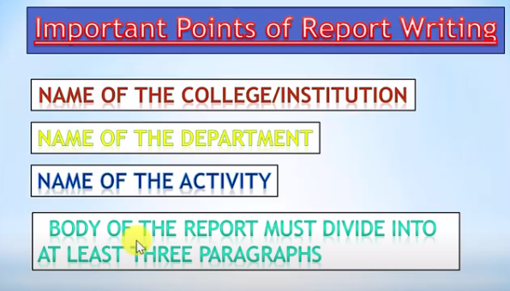
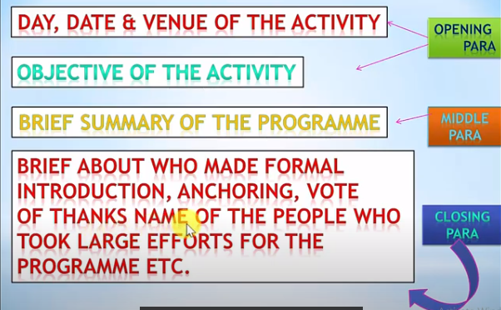
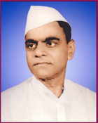
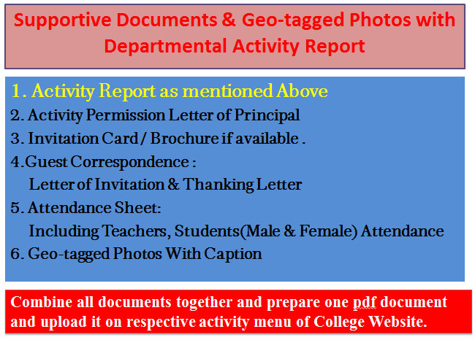
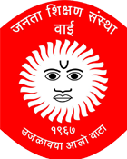
Janata Shikshan Sanstha’s
Kisan Veer Mahavidyalaya,Wai
Department of N. C. C.
HIV/AIDS Awareness Rally
Report
“HIV/AIDS Awareness Rally” was organized by the department of NCC on 30-11- 2019. Hon. Ranjit Bhosale, Tehsil Officer, Wai was invited as a Chief Guest of the program. Lieutenant Sameer Pawar welcomed him with a bouquet.

Hon. Ranjit Bhosale inaugurated the program and explained HIV disease in detailed manner. He enlightened students concerning HIV. Lieutenant Sameer Pawar gave an introductory speech. 80 cadets and the mass attended the program.

Dr. C. G. Yeole Lieutenant Sameer Pawar
Principal NCC Officer
Kisan Veer Mahavidyalay,Wai NCC Unit
2. Activity Permission Letter of Principal

Paste the PDF

4. 4.Guest Correspondence:
Letter of Invitation & Thanking Letter

Paste the PDF
3. Invitation Card / Brochure if available

Paste the PDF

Combine all documents together and prepare one pdf document and upload it on respective activity menu of College Website.
Caption
Caption
Paste the PDF
Paste the PDF
Caption
Caption
Paste the PDF
Paste the PDF
5. Geo-tagged Photos With Caption

Paste the PDF
5. Attendance Sheet:
Including Teachers, Students
(Male & Female) Attendance

